08 Failure Analysis of Plastic (vinyl) Covered Wire Rope Cable due to overload
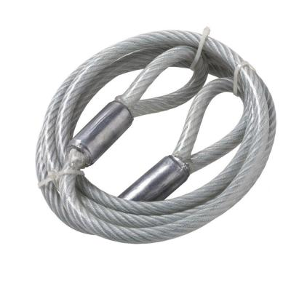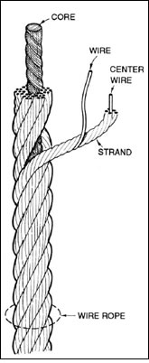
Key words: Cable, Fatigue
Material: Steel
Introduction
A section of a fractured plastic (vinyl) covered wire rope cable was submitted for failure analysis. Two new rope is also sent for comparison. The cable in question appears to have been purchased and installed on August 20, 1999. The owner of the Gymnasium purchased and installed the cable on to the lateral pull-down machine at Gym. The owner testified that he applied a silicon spray to the cable on a weekly basis. The accident occurred on January 21, 2000. Visual examination, mechanical and metallographic analyses was performed on the submitted pipe sections to look for root cause of the failure.

Visual Examination
The wires underneath showed rust spots and entrapped debris, presumably containing corrosion products, Figure 1. A few broken pieces of wires spilled out of the peeled sheathing. Exposed fracture surfaces of individual wires, including the small pieces referred to in the preceding paragraph and the fractured ends of the new wires, were examined under low power stereo microscope, for comparison. The fractured ends of the new wires showed a cup and cone fracture that is typical of ductile material that fails under over load, Figure 2, while most of the fracture ends of individual wires of the failed wire rope cable showed no noticeable necking, Figure3. This examination quite clearly showed that almost all the wires of the failed cable had failed via a progressive (fatigue) mechanism and not by overload alone, as in the case of broken ends of the new wire after testing at a testing lab.
Figure 4: Cup and Cone Fracture on the Tensile Tested New Wire Rope
Figure 3: Rust Spots and Entrapped Debris Underneath Sheathing

Figure 5: Fractured Ends of Wires at the Failure Site

Mechanical Test

